***3DEXPERIENCE*** ***R2025x On-Premises   
Product Data Management with CATIA V5 Integration, Engineering Bill of Materials Management, Document Management, Project Management & Change Management Implementation***

***for***

***Indian Fine Blanks Limited, Automotive Division, Bengaluru***

**Business Blueprint Version 1.0**

DOCUMENT

**Client : Indian Fine Blanks Limited, Automotive Division**

**Address :** IFB Automotive Private Limited #16, Visveswaraya Industrial Estate, 1st Main Road, Off Whitefield Road, Mahadevapura, Bangalore - 560 048.

**Partner : EDS Technologies Private Limited**

**Address** **:** The Estate, 2nd Floor, 121, Dickenson Road, Bangalore-560 042, India

**Document details: Implementation:**

|  |  |  |
| --- | --- | --- |
| **Name** | **Version No.** | **Description** |
| Business Blueprint | 1.0 | This is the document for Scope, Process study, Fit and Gap analysis and Implementation plan for 3DEXPERIENCE On-Premises- Document Management, Project Management, Engineering Release Management, Change Management & Product Data Management with CATIA V5 Integration. |
|  |  |  |

Revision details:

|  |  |  |  |
| --- | --- | --- | --- |
| **Action taken (add/del/change)** | **Preceding page No.** | **New Page No.** | **Revision Description** |
|  |  |  |  |
|  |  |  |  |

Change Register serial numbers covered: None

The documents or revised pages are subject to document control.

These are confidential documents. Unauthorized access or copying is prohibited.

|  |  |  |
| --- | --- | --- |
| **Mr. Srikumar Maganti** | **Mr. Ajay Vani** | **Mr. Salesh NP** |
|  |  | Signed Copy will be posted here |
| **Sr. General Manager [EDST]** | **Vice President** | **IT Head** |

Signed copy will be pasted here

**3DEXPERIENCE On-Premises Implementation Business Blueprint Sign off**

**Project :** 3DEXPERIENCE On-Premises Product Data Management Integration with CATIA V5, Engineering Bill of Materials Management, Document Management, Project Management & Change Management.

**Location** **:**  IFB Automotive Private Limited #16, Visveswaraya Industrial Estate, 1st Main Road, Off Whitefield Road, Mahadevapura, Bangalore - 560 048.

**Project Owner : Indian Fine Blanks Limited**

**Contract No :**

EDS Technologies has delivered the first Milestone of 3DEXPERIENCE On-Premises implementation is as mentioned below.

**Milestone 1: Submission of Business Blueprint**

As per the deliverables mentioned in the purchase order.

|  |  |  |
| --- | --- | --- |
| **Person** | **Designation** | **Signature** |
| Mr. Srikumar Maganti | Project Manager |  |
| Mr. Anil Kundaragi | Functional Consultant  (Primary Support) |  |
| Mr. G N Sudheer | Functional Consultant  (Additional Support) |  |
|  |  |  |
|  |  |  |

# Table of Contents

0. Glossory 6

1. Introduction 7

1.1 3DEXPERIENCE Implementation at Indian Fine Blanks 7

Background of Business Blueprint 7

1.2 Business Drivers 8

1.3 Business Measures 9

1.4 Overview of the Project 9

1.4.1 Project Scope 9

2. Current Design Practice 12

3. Expectation of 3DEXPERIENCE solution 13

3.1 Organizational requirements 13

3.2 Functional Requirements 13

4. Proposed Solution 14

4.1 CATIA V5 Integration 18

4.1.1 Web Based / Role Based Application 18

4.1.2 3DEXPERIENCE Menus / Access within CATIA V5 19

4.1.3 Search for files using 3DSearch with 6WTags features..............……….…...19

4.1.4 Open files from 3DEXPERIENCE to CATIA V5 19

4.1.5 3DEXPERIENCE CSV & IFW Role Apps & Widgets 19

4.1.6 Maturity Status / Lifecycle Management 19

4.2 Project Management 25

4.3 Change Management 25

4.4 General Document Management System 26

5. 3DEXPERIENCE Platform 27

6. Configuration Supporting Data 29

6.1 Verticals 29

6.2 Collaborative Spaces 29

6.3 Document Numbering System 30

6.4 Classification of Document Types 30

6.5 Status Log 31

6.6 Document Version / Revision 31

7. Hardware checks and Infrastructure requirement 32

8. Training Materials / Contents 32

9. Risks and Mitigation 32

10. Post Go-Live Hypercare / Support 34

11. Assumptions & Exclusion 35

12. Implementation Project - Change Request 36

**0. Glossory**

IFB – Indian Fine Blanks Limited

APQP – Advanced Product and Quality Planning

BBP – Business Blueprint

CA – Change Action

CAD – Computer Aided Design

CO – Change Order

CR – Change Request

DCR – Design Change Request

DMS – Document Management System

DOC – Document

E-BOM – Engineering Bill of Materials

ECA – Engineering Change Action

ECO – Engineering Change Order

ECR – Engineering Change Request

EDST – EDS Technologies Private Limited

GUI – Graphical User Interface

NC – Non-Conformance

NCR – Non-Conformance Report

OOTB – Out of the Box (without any customization)

PDM – Product Data Management

PLM – Product Lifecycle Management

RFC – Request for Change

SOP – Standard Operating Procedure

WBS – Work Breakdown Structure

# 1. Introduction

## 3DEXPERIENCE Implementation at Indian Fine Blanks

IFB Industries Limited originally known as Indian Fine Blanks Limited started their operations in India during 1974 in collaboration with Hienrich Schmid AG of Switzerland. The product range includes Fine Blanked components, tools and related machine tools like Straighteners, Decoilers, Strip loaders and others.

The Engineering divisions are located at Kolkata & Bangalore. The Bangalore unit, apart from Fine Blanked components, manufactures motors for White goods as well as Automotive applications

**Background of Business Blueprint**

Based on the business study activities, EDST will generate the document for IFB Industries Limited business practices and understand the functional requirements of this project. The resulting document will be a "Blueprint" of the business when accepted the same will be mapped in the realization stage.

The objective of this Business Blueprint is to agree the scope of 3DEXPERIENCE implementation based on the functionality requirements. Signing of this Business Blueprint gives approval for the 3DEXPERIENCE project to proceed further.

## Business Drivers

The primary drivers for 3DEXPERIENCE Implementation are as follows:

* Seamless integration of CATIA V5, Generation of EBOM with 3DEXPERIENCE platform
* Establish data management design within the PLM eco-system for single source of truth
* Improving efficiency & effectiveness by eliminating manual work
* Centralized document management system with traceability
* Establish paperless environment by releasing data in electronic formats
* APQP Processes & Projects through 3DEXPERIENCE - Project Management
* ECR, ECO & ECA through 3DEXPERIENCE - Change Management
* Organization Workflows & Approvals through 3DEXPERIENCE - Route Management

In short, 3DEXPERIENCE will be used to introduce the best design management practices and elevate the status of Indian Fine Blanks Limited as one of the best-managed companies in the industry.

## Business Measures

Business measures are the implementation goals to measure the success of the project, specifically the business-related goals. These measurements serve as the basis for measuring the success of the 3DEXPERIENCE implementation project. The following are the business measures finalized for **Indian Fine Blanks Limited** 3DEXPERIENCE Implementation.

* Standardized processes for design data management across the organization
* Flexible system to facilitate single source of truth
* System covering all design critical business processes
* Avoiding data redundancy, maintain consistency of data and minimize the workload involved in entering and updating data

## Overview of the Project

EDS Technologies will be addressing **Indian Fine Blanks Limited** design data management business problems through the utilization of 3DEXPERIENCE licenses.

EDS Technologies to build 3DEXPERIENCE configuration to manage design data, E-BOM management, project management, change management, document management, as part of the scope.

EDS Technologies will be activating 3DEXPERIENCE On-Premises tenant in test and production servers utilizing the available content repository to store documents.

### Project Scope

The scope of the project includes:

* Installation of On-Premises 3DEXPERIENCE Platform in Test & Production Servers.
* Implementation of
  + CATIA V5 Integration with 3DEXPERIENCE
  + Document Management System (DMS)
    - Status / Lifecycle management
    - Revision management
    - Review & Approvals
    - Document template standardization
    - Microsoft Office Integration
  + EBOM & Part Numbering
  + Change Management.
    - Change Request
    - Change Order
    - Change Action
  + Project Management
    - APQP Management
    - Phase Definition, Task Dependencies & Project Status
    - Resource Allocation
    - Different Graphs - Gantt Chart, Burn down chart, Plan vs Actual, ...

**The detailed scope is as follows:**

|  |  |
| --- | --- |
| **Scope** | **Capabilities** |
| **CAD Integration CATIA V5 With 3DEXPERIENCE** | * Integrate CAD application with 3DEXPERIENCE system. * Centralized repository for design data management & associated documents. * Revision management * Lifecycle (Maturity status) management. * Review and approval workflows. * Change Action Management. * Collaborative tasks management. |
| **Collaborative Industry Innovator & 3DSwymer**  Consisting of the below functionalities:  3DMarkup, 3DDashboard, 3DPlay, 3DSearch, 3DSwym App, Bookmark Editor  Change Action, Classify & Reuse  Collaboration & Approvals  Collaboration for Microsoft,  Collaborative Lifecycle,  Collaborative Spaces, Control Center  Collaborative Tasks, Compare,  Enterprise Control Center,  IP Classify & Reuse,  Issue 3D Review,  Issue Management,  Product Explorer,  Route Management. | * **Collaborate Effectively –** Securely access, share and manage documents and data. * **Enable Concurrent Design –** Manage the product structure as data on the 3DEXPERIENCE platform so designers can work in parallel. * **Reduce Rework and Delays –** Easily classify and search for parts that meet requirements in standard or company part libraries. * **Stay Organized –** Intuitively organize, view, and track individual and shared tasks from creation through completion. * Manage documents and data, including CAD data from CATIA V5. * **Collaborative Lifecycle Management –** full lifecycle management support throughout creates review, release, and obsolescence phases. * **Product Structure Review –** provides a unified product definition that can filter to show a CAD product structure or a Bill of Material (BOM). * **Advanced Navigation and Filter –** Find items of interest quickly using to filter the product structure based on diverse criteria, including the product configuration. * **IP Classification for Reuse –** Classification of content with standard or “user defined” Tags enable easy search and reuse of intellectual property. * **Collaborative Tasks –** Users can easily organize, enhance and access their work using tasks. |
| **Microsoft Office Document Management** | * Manage documents with version & status. * Creation of standard document templates. * Creation of relevant workspaces and folder structures. * Setting up default attributes on documents and attribute group definition. |
| **Engineering BOM Management** | * Manage E-BOM and product structure against the designs created. E-BOM Templates, EBOM attributes configurations, E-BOM Item logics & Formats. |
| **Change Management** | * For end-to-end change process, create change request, attach the affected item, perform impact analysis on the affected item, create change order for the change request and then later create change action for the change order. * For quick change process, create change request, add affected item and complete change action. |
| **Project Management** | * Project Templates for processes, Workflow definition, WBS Structure, Configuration, Reminders & Notifications, Dashboard Configurations, Bookmark (Folder) structure, Collaborative Space, Issue & Risk templates, Experiments & Baseline configurations. * Configuration of tasks & deliverables for Product Design using Microsoft-Excel templates with notification & manual inputs wherever applicable. * Utilization of OOTB functionalities of the solution for updating of project document / deliverables with manual intervention as applicable, also to receive notifications as per the organization requirement. |

The term ‘**Object**’ in the document represents, **Product/Part/Drawing/Document** etc., according to the application used.

# 2. Current Design Practice

Currently the practice on design activities categorized as

Design & Development Team – Comprises of design engineers working on CATIA V5, systems.

The **current design team** structure is as follows:

The team includes design engineers who report to the Design Head for design-related approvals. CATIA V5 applications are used by designers to create 3D & 2D design data.

All designs created are stored in a folder-based system. Approvals are manually   
  
processed. After approvals, Documents are moved to Product Document. Currently, part numbers are managed in excel for the parts or assemblies created by the design team based on model number.

# 3. Expectation of 3DEXPERIENCE solution

## 3.1 Organizational requirements

* Establish a collaborative environment across the R&D, other functions within & outside the organization
* Eliminate manual activities, avoiding data redundancy, maintain consistency of data and minimize the workload involved in entering and updating data
* Establish single source of truth on design data across the organization
* Establish paperless environment by releasing data in electronic formats

## 3.2 Functional Requirements

* Integrate CATIA V5, with 3DEXPERIENCE platform for managing all design data.
* Manage designs and associated data in a centralized repository / document management system.
* Collaboration with Microsoft Office Integration.
* Capturing the requirements.
* Manage & have a complete understanding of the Projects at any given point of time.
* Status / Data lifecycle management to manage reviews & approval mechanism with necessary notifications.
* Version / Revision management for design document control.
* Change Management for design control.
* E-BOM & Part Numbering management.

# 4. Proposed Solution

3DEXPERIENCE Implementation will utilize the CATIA V5 integrations, EBOM Management, change management, Project management, Document management system with Microsoft Office Integration, and other associated components by activating & configuring the process as per the requirements captured during the BBP & SOP discussion. 3DEXPERIENCE solution will enable the following functionalities.

|  |  |  |  |
| --- | --- | --- | --- |
| **Sl. No.** | **Scope** | **Current Practice** | **Proposed Solution** |
| 1 | Engineering Document Management | All the CAD data are currently saved on local systems with revisions manually maintained or overwritten.  Product Design structure is created in CATIA V5, components in data are saved in local folder-based system. | 3DEXPERIENCE – Integrated system will be configured for CAD data management and bring in connectivity across all related business function. All data going forward will be saved in 3DEXPERIENCE content server that carries unique document numbering based on 3DEXPERIENCE number ranges and accessed from the same. Associated documents like word, excel etc will also be managed.  The Product design structure created in CATIA V5, will be saved in 3DEXEPERIENCE content server and accessed from 3DEXEPERIENCE once integrated.  New part / product creation, insert existing part, import / export & save of design data will be facilitated and made available in 3DEXPERIENCE platform.  CAD Software levels must be compatible as per the Dassault Systemes Program directories. [Program Directories Library](https://media.3ds.com/support/progdir/all/?pdir=3Dexp,r2024x,update07&context=onpremises) |
| 2 | Status (Maturity) Management | Currently these are managed in Folder where the release documents are managed. The process is manual in nature with drawing prints taken physically to the reviewer / approver. | The document statuses like In-work, request for approval, frozen & released are configured for each document. Route/Workflow templates with tasks will be configured for necessary approvals wherever required. Mail triggers & notifications for approval process will be enabled through routes & task management |
| 3 | EBOM Management | Currently there is no system in place to manage the EBOM. Excel is being used to manage the EBOM & Part Numbering & there is no auto sync between CAD & EBOM excel. | EBOM management process will be configured as per the inputs provided by Indian Fine Blanks Limited team to manage the EBOMs in 3DEXPERIENCE platform. The part number logics can be defined, but as per IFB it will be Manual entry. |
| 4 | Revision Management | History of data is maintained manually through Printouts. However, the revision & statuses of design data are maintained at many levels manually and there is no link between the documents. | History with revision & statuses of design data will be maintained at primary levels in 3DEXPERIENCE and CAD data. Primary revisions such as A, B,C,D etc. for all CAD data will be maintained in the platform. Two revision schemes cannot be maintained for CAD data. |
| 5 | Change Action Management | Currently change action management practice is done manually through Design Change Request (DCR) document. | End to end of change management process will be configured if required to manage the change actions where the user will be able to create change request, change coordinator will perform change order and assign resources to manage the change on designs in change action. |
| 6 | Review / Approve of designs | Currently the review / approvals are manual in nature made on the drawing print outs taken physically by the user.  **Note**: All approvals & workflows are managed through mails | Routes/Workflows will be configured that will automate the process of review & approvals done within the 3DEXPERIENCE platform. Once the design is frozen by the designer, he creates a route to notify the reviewer & approver requesting for an approval to release the design if no changes suggested by them. If any changes are required, the reviewer rejects the design which notifies the user to make those suggested changes and initiates route for final approval. |
| 7 | Project Management | Currently projects are managed through Microsoft Excel.  For project communication emails are being the primary source. | Create Project Templates for processes, Workflow definition, WBS Structure, & Notifications, Dashboard Configurations, Bookmark (Folder) structure, Collaborative Space, Issue, Experiments & Baseline configurations.  Configuration of tasks & deliverables for Product Design management.  Utilization of OOTB functionalities of the solution for updating of project, document / deliverables with manual intervention as applicable. |
| 8 | Change Management | Currently change management practice is done manually through Design Change Request (DCR) document. For change communication emails are being the primary source | Create Change Request with affected item and impact analysis is done, once Change Request is valid, then Change Order is created, and later Change Action is created allotting the task to the concern person. |
| 9 | General Data Management | Currently managed manually in Folder system with create / open /save onto folders. | 3DEXPERIENCE will be integrated to Microsoft Office applications with necessary configuration for data management including version/status management, as per the requirement and establish connectivity within the R&D eco-system.  Microsoft Office must be compatible as per the Dassault Systemes Program directories. [Program Directories Library](https://media.3ds.com/support/progdir/all/?pdir=3Dexp,r2024x,update07&context=onpremises) |

Only OOTB (without any customization) features will be used and configured for IFB, which does not include any customization scope.

## 4.1 CATIA V5 Integration

### 4.1.1 Web Based / Role Based Application

Connector for CATIA V5 delivers just the right data management functionality in a simple and familiar interface. It is directly integrated into the desktop and CATIA V5 interface, completely removing the need for users to learn a new way to do what they’ve done for years: manage their models and drawings quickly and easily.

The CATIA V5 connector on the 3DEXPERIENCE platform provides a user experience avoiding serious disruption in the design management and practices used today.

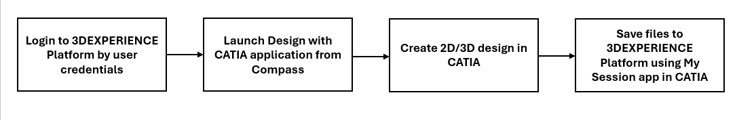

The integration between 3DEXPERIENCE & CATIA V5 is established when the “Design with CATIA V5” app is used by the users at their first login which triggers installation of native apps onto their local system. After necessary installations, when the users log into the 3DEXPERIENCE platform and launch “Design with CATIA V5”, this time the user will be able to open CATIA V5 from 3DEXPERIENCE.

### 4.1.2 3DEXPERIENCE Menus / Access within CATIA V5

The CATIA V5 is starting up from within 3DEXPERIENCE. Alternatively, the users can start CATIA V5 from their desktop and then login to 3DEXPERIENCE platform as well.

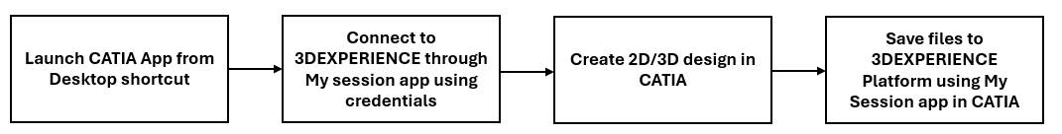

Hence many ways of accessing CATIA V5 on 3DEXPERIENCE are available as choice for the users to work with as per their convenience.

The commands & options of 3DEXPERIENCE are accessible within CATIA V5 for accessing / saving design files and perform all PLM functionalities from within.

### 4.1.3 Search for files using 3DSearch with 6WTags features

### 4.1.4 Open files from 3DEXPERIENCE to CATIA V5

### 4.1.5 3DEXPERIENCE CSV & IFW Role Apps & Widgets

### 4.1.6 Maturity Status / Lifecycle Management

Maturity or lifecycle states of CATIA V5 design / engineering data provide information about the content completion ratio and validity. Content reaches a specific maturity state based on the business process criteria and conditions. The generic lifecycle used by most engineering content controls how users create, release, revise, and eventually, make content obsolete.

Below are the out of the box maturity statuses configured for all CATIA V5 data across its lifecycle.

User request for review & approval from managers with Routes & Tasks

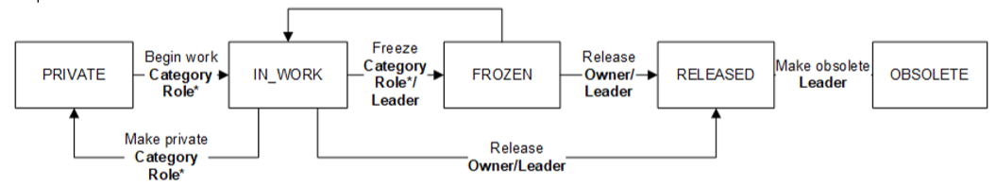

* **Description about each status**

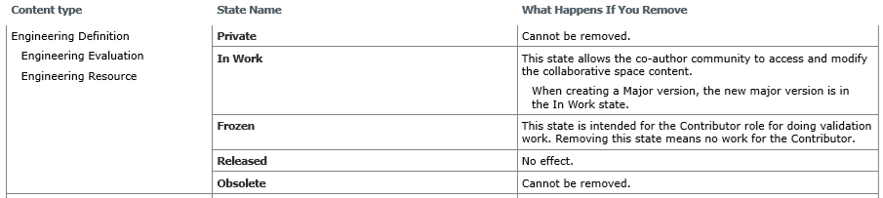

The out-of-the-box business processes speed and simplify work. Many aspects of these business processes are implemented within lifecycles. For example, object access rights are defined and associated with lifecycle states. The apps use triggers attached to states to execute control checks.

When a user promotes content for an approval request to review, check and approve through routes & tasks which triggers notification to the respective approvers / reviewers. In addition, the lifecycle for specific content types can restrict where you can add additional transitions. The content could have rules associated with a transition. Rules define conditions that must be met prior to promoting the content to the next state.

**Engineering Bill of Material**

**Assigning Part Numbers:**

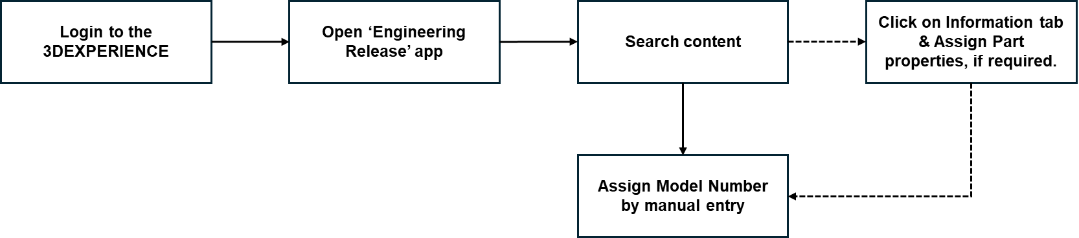

* Once the Part Number (Enterprise item number) is assigned, the counter will be consumed. This cannot reset.

**Revision Management**

The user can update the revision of one or more parts to any later revision, not necessarily the latest revision. The later revision can be either released or unreleased. This feature lists all the parts in the BOM that have later revisions. Users can then select for each Product/Part the revision to which it has to be updated. The changes take effect throughout the BOM.

After a part is updated to the latest revision the users get approvals before the part / assembly / drawing must be released that goes through a route with task workflow with mail notifications. The user will fill in the relevant parameters such as Approved by/ Checked by mandatorily to release the CAD files to released state.

The Revision representation logic format will be in the Alpha sequence that starts from A, B, C … (Only one revision scheme can be maintained for CAD).

Post the released state, in case the user wishes to change the design, the user follows the change management process which can trigger a lifecycle, seeks an approval to generate the change action number and then assign relevant resources to complete the action.

**Change Actions**

You use a change action (CA) to manage an implementation of a change-required object. Contributors, Authors, and Leaders can create change actions in their collaboration space. CA can be manually created or generated from the proposed changes.

There are two ways to manage changes with a change action. The first method is to add objects to a CA that need to be changed as proposed changes. When objects are added as proposed changes, the default operation and activity are automatically set based on maturity and whether the object is configured or not. When proposed objects are added for revisioning, change automation will create new revisions when the CA is moved to In Work state.

The second method is to use 'work under', in which you make changes directly by working under the selected change action. Using this method, proposed changes are optional. When you make change using work under, the changes are automatically logged as realized changes. The details of Work Under in 3DSpace, 3DDashboard, and the Native app can be found in the corresponding Work Under section.

**Route Management**

When a user completes a design and must be reviewed / approved, the next member - reviewer in the design cycle must be informed. The 3DEXPERIENCE allows you to set up a process for this called a Route. The route allows you to specify the list of users who should receive the scheduled tasks through notifications along with the instructions informing them about their assigned tasks.

*For Example*, a route can define who needs to view, review or approve an object before it can be promoted to the next state on its lifecycle.

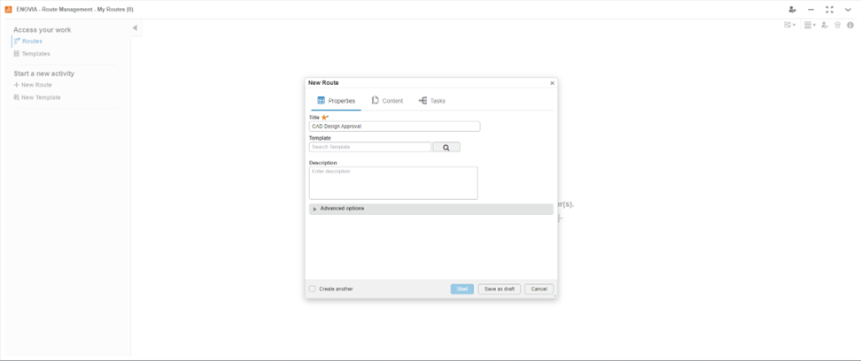

A simple route is the easiest to define. It can have one or more members, each with the same route action (for example, Approval, Review, or Notify Only) and the same due date. This workflow shows an example of a simple route.

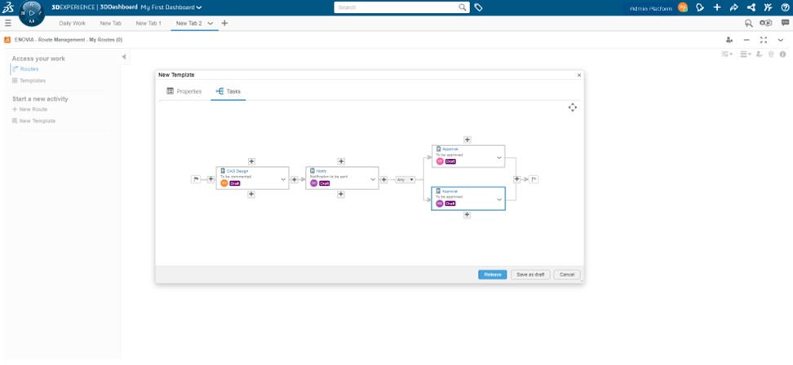

Sample Route process as shown below

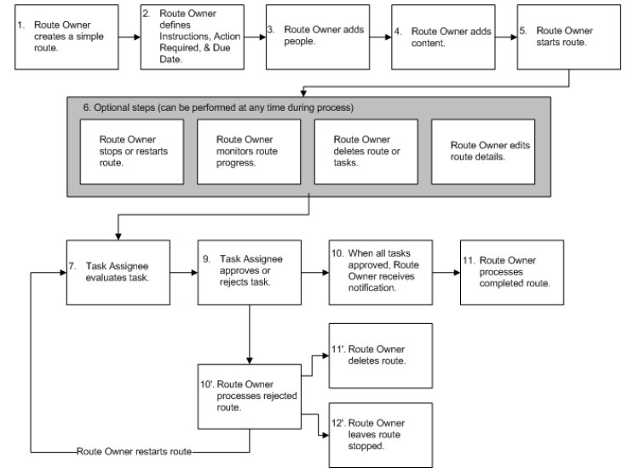

## 4.2 PROJECT MANAGEMENT

Deliverables-based project management links product development data to a project, enabling real-time monitoring and assessment to improve project performance. Project manager provides deliverables-based project management that links product development data to a project to enable real-time monitoring and assessment.

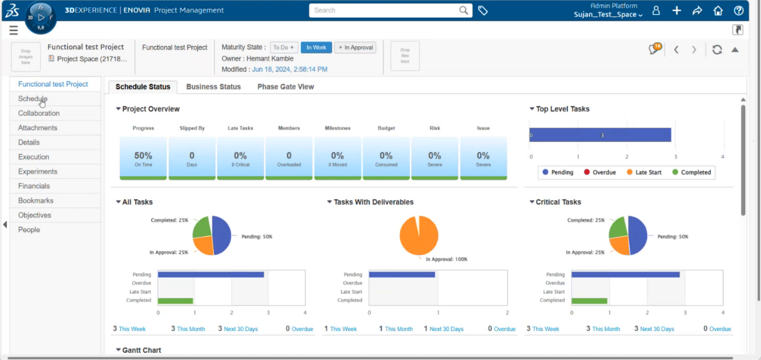

Project managers no longer need to consult multiple systems nor spend time manually collecting project status from team members project managers can focus more time on true project management activities: evaluating progress, identifying and reducing risks, and aligning resources to maintain or accelerate schedules. The implications of portfolio decisions can be quickly assessed against the project schedule. As a result, a project manager can more easily understand and resolve issues significantly improving project execution and performance.

## 4.3 CHANGE MANAGEMENT

Currently Indian Fine Blanks Limited is maintaining change management through mail. Change management in 3DEXPERIENCE is a strategic close-loop collaborative change process that clearly communicates change decisions and assignments to all impacted domains. Features are detailed below:

* Bring organizations together under a single change methodology while accommodating unique organizational needs.
* Make informed decisions by obtaining a full impact assessment of change requests from all impacted organizations.
* Clearly communicate change decisions and assignments to all impacted organizations.
* Improve product development quality by establishing governance standards for the entire enterprise to adhere to.
* Reduce time and cost associated with iterative, error prone change orchestration and synchronization scenarios with intelligent change management rules and automation.

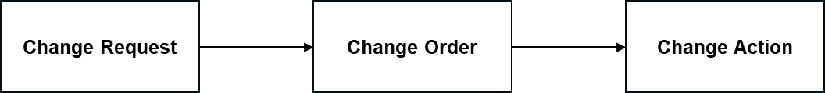

## 4.4 GENERAL DOCUMENT MANAGEMENT SYSTEM

The generic document management of non-engineering objects like office documents comprises a range of functions for managing documents that may be stored in 3DEXPERIENCE System. Document Management offers a wide range of functions for managing product documentation and ensuring problem-free data exchange between different applications.

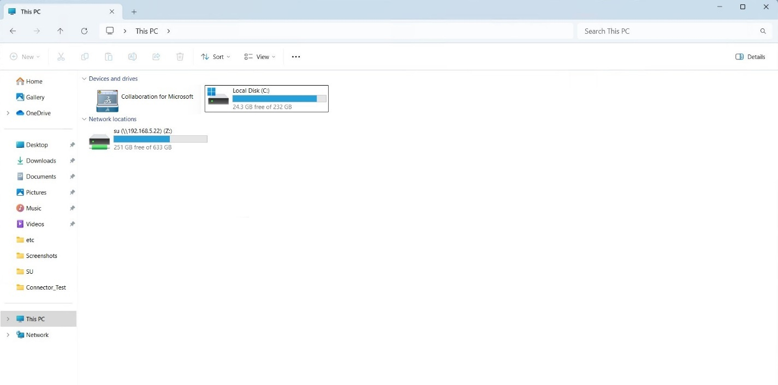

3DEXPERIENCE Microsoft Office collaboration integrates Microsoft office applications with 3DEXPERIENCE, wherein 3DEXPERIENCE menu is available within Microsoft office applications for all document management needs.

In Indian Fine Blanks Limited the Document Management System will play a vital role in data management, and one such situation is in management of all documents linked to relevant tasks or activities. The quality and availability of documentation is becoming increasingly important. The document management system in 3DEXPERIENCE system offers the best to address such situations.

## 5. 3DEXPERIENCE Platform

3DEXPERIENCE GUI is the [I](http://en.wikipedia.org/wiki/Graphical_User_Interface)nterface client / front end interface that runs on [Microsoft Windows](http://en.wikipedia.org/wiki/Microsoft_Windows), which allows a user to access the functionality in applications such as [3DEXPERIENCE](http://en.wikipedia.org/wiki/MySAP_ERP) platform.

3DEXPERIENCE GUI is directly connected to 3DEXPERIENCE platform. Whenever a user logs on to GUI the user can access the relevant application / apps which are deployed as part of the system. 3DEXPERIENCE provides the URL link to user to access all related information.

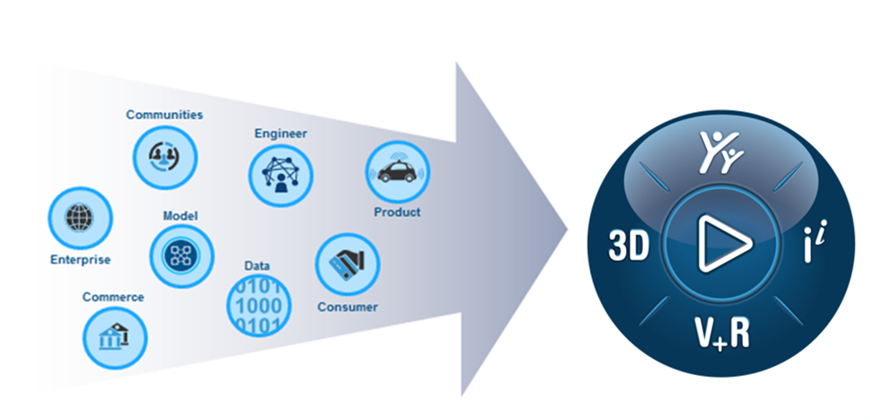

EDST is excited to collaborate with Indian Fine Blanks Limited on its journey to transform its business through the 3DEXPERIENCE platform. The 3DEXPERIENCE platform is a unique business platform in the industry, which enables our clients to create delightful experiences for their ultimate customers.

The platform is oriented towards digitally connecting all data streams in a value chain to help engineers model the end customer product experience.

This fundamental shift in approach leads to efficiency and accuracy improvement in day-to-day design collaboration.

The platform gives you a scalable and modular approach to expand process adoption without going into multiple systems integrations. There are more than 500 Apps on offer on the platform which cater to all departments/user profiles in a company – and over a period, this gives an option to digitally connect all actors in the value chain – including suppliers.

However, as per the current licenses made available to Indian Fine Blanks Limited below are some of the apps & widgets available for use that will be configured accordingly to relevant users based on their activities.

**Platform Management – User & Roles management**

Using the platform management dashboard app, the necessary users and roles can be added onto the 3DEXPERIENCE platform who would be part of the system.

All the licenses are activated, and currently respective roles can be assigned to the users.

* Members – 17
* Project Manager – 02
* CAD Connectors – 05 (Design with CATIA V5)
* Change Manager – 01
* Product Release Engineer -01

The designer role will provide access to users to work on CATIA V5 in 3DEXPERIENCE with provisions for write / modify & read access, while the reviewer / approval role will have access to view the designs and approve / reject as part of the approval matrix.

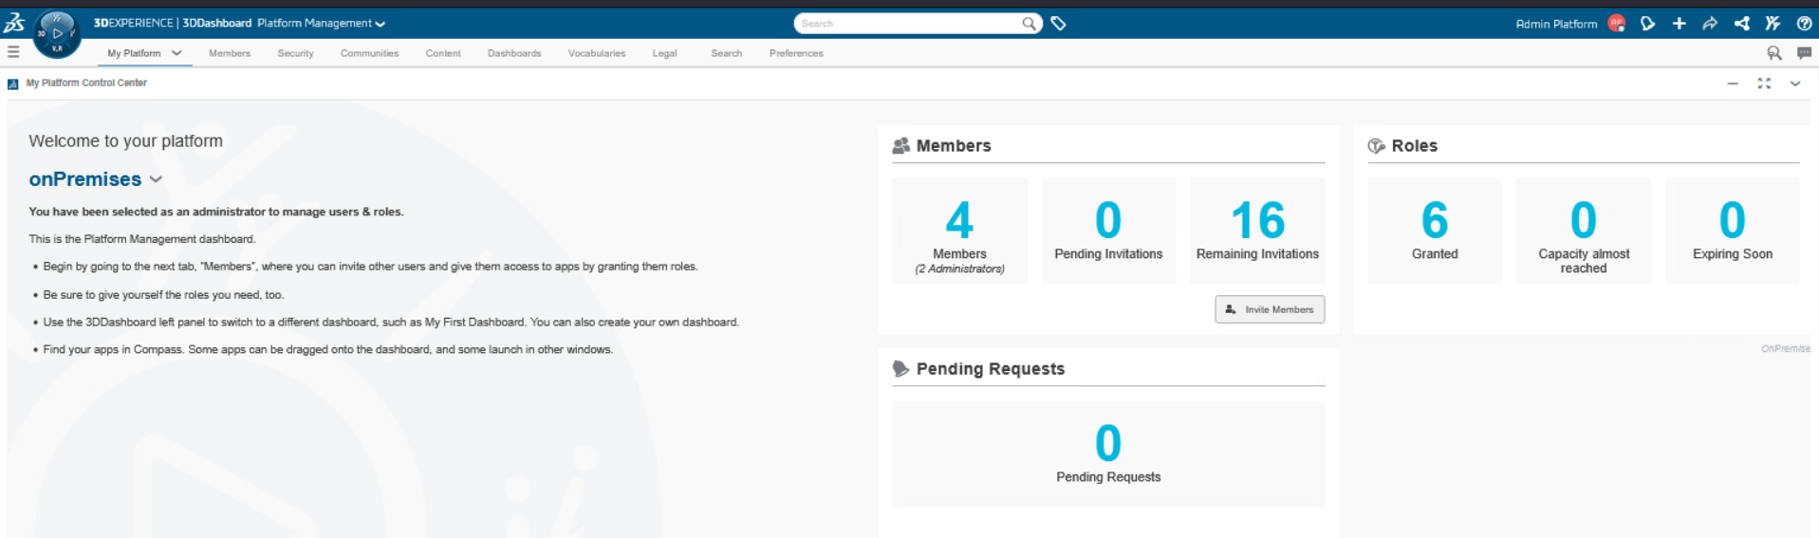

The users tab allows you to add the respective user types like member, admin.

The role tab allows us to add the roles to that specific user as shown below as some sample roles available as per the license availability.

# 6. Configuration Supporting Data

## 6.1 Verticals

The 3DEXPERIENCE implementation is being carried out to meet the expectations of Indian Fine Blanks Limited.

## 6.2 Collaborative Spaces

Organize content to manage who can access that content, and when users from other collaborative spaces can access the content.

Security mechanisms are built around collaborative spaces. The collaborative space, with the role and organization, comprises the credentials that control user access to content.

Within a collaborative space, all users work as a single team for any app. All members of the collaborative space with the same role have the same content access rights. The collaborative space, not the user, owns content created in that space. The collaborative space Owner can change the baseline behavior by defining access rules to take advantage of mechanisms such as strict ownership, reservation, and transfer of ownership.

Two collaborative spaces will be created for the users to work as per the usage,

1. Test Data – For all testing purpose.
2. Production Data – For live design data management.

## 6.3 Document Numbering System

This is the Numeric field that is autogenerated for every design document. The document number, or in short, document, identifies a document as the main part of a document key.

**Part Numbering:**

## 6.4 Classification of Document Types

As the process requires involvement of other documents in completing the processing of any design documents or non-engineering document in cases along with supporting documents and for the ease of identification, the individual departments are broadly classified as below:

3DEXPERIENCE platform classifies the documents out of the box as CATIA V5, Microsoft files such DOC, XLS etc.

|  |  |  |  |  |
| --- | --- | --- | --- | --- |
| **Sl. No.** | **Doc Type** | **Description** | **Series** | **Vertical** |
| 1 | .CATPart, .CTAProduct, .CADDwg | CATIA V5 files |  | - |
| 2 | XLS | Microsoft Excel | XLS | - |
| 3 | DOC | Microsoft Document | DOC | - |

## Number Range for Change Action Management

System generated auto number range is defined for each change action initiated if utilized.

## 6.5 Status Log

The status log is a record that gives us a one-line explanation about the statuses of a document has already had with some of the details like which user had changed the status of the document, which date, what time, and a small explanatory log field which helps to inform the status. A log field informs about any changes to the status.

## 6.6 Document Version / Revision

Document versions are used to represent the different change or delivery statuses of a design. In all the document types, versions start from 1,2,3, ... The version is autogenerated.

Document revisions are used to represent the change of the document after the document is released. In all the document types, revision starts from 0,1,2,3, ... The revision is also autogenerated.

# 7. Hardware checks and Infrastructure requirement

Necessary internet connection is required to access the 3DEXPERIENCE Premises tenant.

# 8. Training Materials / Contents

Video recordings and training manuals limited to the scope covered in this document will be prepared and shared to Indian Fine Blanks Limited team for future reference.

# 9. Risks and Mitigation

EDS Technologies have identified the following risks and mitigation for the project. However, the same will be updated when the project progresses.

|  |  |  |  |
| --- | --- | --- | --- |
| **SL No** | **Identified Risk** | **Risk Owner** | **Mitigation** |
| 1 | Ability to deliver the solution from EDST | EDST | EDST is deploying experienced consultants who have handled similar projects. |
| 2 | Timely requirement sign-off | Indian Fine Blanks Limited. | Signing off the requirements become very important for the timely deliverables. Indian Fine Blanks Limited needs to sign-off the requirements within 2 days from the blueprint delivery by EDST consultants |
| 3 | Co-ordination between teams of Indian Fine Blanks Limited and EDST functional consultants for Specifications and Testing completion | EDST & Indian Fine Blanks Limited. | Both parties should ensure that teams complement each other. It is the sole responsibility of Indian Fine Blanks Limited to ensure that partner consultants are available for configurations, installations, and development at the right time of project duration. |
| 4 | Product related issues which can affect the project timelines / deliverables | Indian Fine Blanks Limited & EDST | Project team will raise tickets and continuously monitor to obtain response from team. For some reasons, if it is unable to resolve the product issue within the project timeline, that requirement will be parked and mutually agreed for a workaround. |
| 5 | Consultant continuity during the project | EDST | EDST will ensure that the consultants deployed to the project maintain the continuity irrespective of attrition if any. |
| 6 | Scope creep or additional requirement during project execution affecting timeline | Indian Fine Blanks Limited. | Any additional requirement will be taken separately, and a roadmap will be presented to Indian Fine Blanks Limited team for taking up during later stage |

# 10. Post Go-Live Hypercare / Support

Post Go-Live support (telephonic, email & web support) will be provided for a period of about 2+ weeks as part of this implementation from the date of system going live at Indian Fine Blanks Limited to ensure continuity. During this phase, we shall be supporting users in the production environment on functional requirements (excludes training) restricted to implemented solution, communication, and issue resolution via our team.

Beyond the hyper care support, regular support will be provided to Indian Fine Blanks on functional requirements (excludes training) restricted to implemented solution, license management, communication, and issue resolution via our team.

Additionally, the users can raise service requests / tickets to Dassault Systemes for any issue resolution / software defects using the valid DS login credentials.

Further, access to IFWE communities will be provided for relevant users to post their queries, seek expert suggestions & inputs, best practices tips & tricks and for many other useful information.

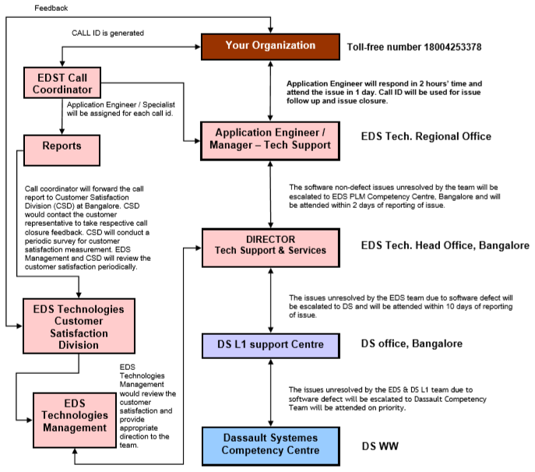

# 11. Assumptions & Exclusion

* Functional team from Indian Fine Blanks Limited if any will provide inputs wherever needed.
* IT support for access, authorization and others will be provided by Indian Fine Blanks Limited.
* Any interface to non-system that is out of the scope is not covered under this BBP.
* Any requirement arises post BBP sign-off will be based on the evaluation and on need basis, will be done at an additional cost.
* Automation / Customization is out of scope.
* In case after accepting BBP or after commencement of project, a requirement arises from Indian Fine Blanks Limited for new locations or introduction of new business lines at existing locations, EDST will submit a separate proposal for the same.

# 12. Implementation Project - Change Request

**Request for Change (RFC)**

In the event of changes to the initial user requirements requested by Indian Fine Blanks Limited, the same shall be incorporated into the project plan and estimate of effort and delivery schedule will be revised based on the extent of changes requested. Indian Fine Blanks Limited shall approve the changes in plans and revised estimates in time for implementation. The revised schedule and cost shall be incorporated to the contract as amendments. EDST will re-evaluate any substantiate changes from the baseline requirements and technical requirements and will follow the Change Management Process, which typically is like below.

| **Activity** | **Component** | **Responsibility** |
| --- | --- | --- |
| Request for change (RFC) | Change Request form | EDST / Indian Fine Blanks Limited. |
| Study the impact of the change | Impact Analysis form | Review Committee |
| Efforts estimate due to impact | Estimation Template | EDST |
| Schedule Change | - | EDST with Indian Fine Blanks Limited consent |
| Approval of Cost due to effort revision | - | Indian Fine Blanks Limited |
| Sign off on efforts to impact | Impact Analysis form | Indian Fine Blanks Limited |
| Incorporating the changes | Development Life Cycle | EDST |
| Acceptance | - | Indian Fine Blanks Limited |
| Change Request Closure | Change Request Form | EDST |

**Change Control Process**

A change is initiated by a Request for Change (RFC). This is done by filling out a copy of the change request form (CRF) and submitting the same to a Review Committee composed of Indian Fine Blanks Limited. Project Manager and EDST Project Manager and/or their designates. Parties in writing will agree on the membership of the Review Committee on commencement of the project. RFC can be initiated by Indian Fine Blanks Limited or EDST.

The Review Committee will evaluate the RFC for technical validity and its impact on the project. It will also decide which party is responsible for implementing the change. If approved by the Review

Committee, the RFC will be forwarded to the party responsible. The party responsible will also be known as owner for the RFC. For urgent RFC’s, a time will be stipulated by which the party should respond.

**Response to RFC**

RFC owner will, within stipulated time of receiving an RFC approved by the Review Committee, provide the customer with written acknowledgment of the receipt, and estimate of time and effort required to analyse the RFC and prepare the Revised Proposal.

Depending on extent and complexity of the requested change, EDST may charge for the effort required to analyse the RFC and prepare Revised Proposal. In such instances, EDST will notify the customer in writing of the estimated cost. The customer may recall the RFC after receiving EDST's acknowledgment and estimate. Following receipt of the customer's written approval of the estimate and agreement to pay the cost, if any, EDST will, within time specified in the estimate prepare the Revised Proposal. Costs, if any, will be invoiced at EDST's billing rate at that point of time.

The Revised Proposal will detail the impact of proposed change on the following:

**Baseline Documentation**

The impact on the baseline documentation will be defined in terms of the number of pages added, changed, or deleted for each document.

**Equipment**

The impact on Hardware/Networking/Other equipment will be determined. For example, additional hardware/link may be required, or the current one needs to be replaced.

**Scope of Work**

The impact on the scope of work will be defined in terms of new modules, functionality, customization, and implementation.

**Testing**

The impact on testing will be defined in terms of change to the Acceptance Test Plan, test cases, and/or retest period.

**Performance**

The impact of the change on system performance, if any, will be determined. If additional or changed hardware/software/networking elements are required, they will be identified.

**Other Materials**

The impact on other deliverable materials will be listed.

**Resources**

The additional resources required to make the change will be defined and justified.

**Schedules**

The impact on schedule will be shown in terms of impact on the Project Schedule, Delivery Schedule, and End Date of the Agreement.

**Cost**

Total Cost of the change will be estimated.

**Change Request Approval by Indian Fine Blanks Limited.**

Indian Fine Blanks Limited approval is required at two stages.

* Approval for Assessment of Change Impact, and,
* Approval for Implementation of Change.

When a Revised Proposal requires a change to the cost or schedule or when a change is required to this agreement, the change must be approved by the customer's authorized representative in writing. Once approved by the customer, Revised Proposal is added to this agreement. If Revised Proposal is not approved by appropriate authority, owner will not take any action on the same.

**Redefining Scope in Revised Proposal**

After Indian Fine Blanks Limited approval, owner will implement Revised Proposal in accordance with the agreement. Affected portions will be changed and tested as proposed in the agreement.

**Proposal Acceptance by Indian Fine Blanks Limited**

The Revised Proposal will be accepted by Indian Fine Blanks Limited after the change is successfully tested as per the updated Acceptance Test Plan.

Changes made